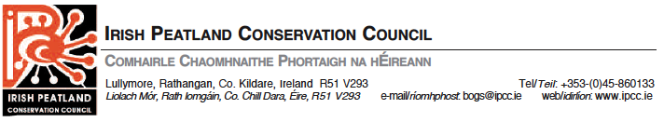

Ireland’s National Blanket Bog Survey

Note: If you are completing this survey electronically then please highlight your answers.

1. Ireland supports 2 different types of blanket bog. Atlantic blanket bog (from sea level to
200m) and Mountain blanket bog (located >200m).
Please select how much of Ireland you think is covered by these two habitats.
◻ 1% ◻ 5% ◻ 10% ◻ 20% ◻ 50%

2. What do you think is the greatest threat to blanket bog habitat? (Choose one)
◻ Hand Cutting ◻ Mechanical Cutting ◻Overgrazing
◻ Afforestation ◻ Recreation ◻ Invasive Species
◻ Fire ◻ Erosion ◻ Dumping
◻ Wind Farms ◻ Pollution ◻ Water Extraction
◻ Telecommunication Installations

3. Have you visited blanket bog recently and what was the primary purpose of your visit?
◻ Yes ◻ No

◻ Recreation ◻ Turf Cutting ◻ Farming
◻ Other (Please Specify)

4. Do you know the name and county of the site?

5. Have you witnessed any of the following activities on the site you visited?
(Please select all that apply)
◻ Turf Cutting ◻ Forestry ◻ Grazing of animals
◻ Drainage ◻ Boardwalks ◻ Wind Farms
◻ Invasive Species ◻ Tourism/Recreation ◻ Fire/Burning
◻ Pollution ◻ Water Extraction ◻ Fishing
◻ Bee Keeping ◻ Dumping ◻ Interpretive or other signage
◻ Erosion/Landslides ◻ Nature Conservation Management
◻ Telecommunication Installations

Other (Please specify)
6. Did you see any of the following indicator species?
◻ Red Grouse ◻ Golden Plover ◻ Golden Eagle
◻ Red Kite ◻ Hen Harrier ◻ Irish Hare
◻ Common Frog ◻ Bog Cotton ◻ Sphagnum Moss

7. Do you feel that more needs to be done to protect blanket bog in Ireland?
◻ Yes ◻ No

8. How would you rank Ireland’s success to date in conserving blanket bog habitat?
◻ Very poor ◻ Poor ◻ Average
◻ Good ◻ Very Good ◻ Don’t know

9. What would you prioritise in ensuring the future of blanket bogs in Ireland?

10. If you would like to report on another blanket bog habitat we will send you another survey
form. Please provide details of your preferred method of contact.

Email:
or
Name:

Address:

The Irish Peatland Conservation Council thank you kindly for your participation.

Please send your completed survey via email or by post using the respective address above.

